**EXERCISE NO. 7: RECRUITMENT**

In the employee referral process, the HR head of the region where a vacancy exists informs employees of that region and other regional HR heads. The other regional HR heads inform employees by putting up a notice informing them about the vacancy. The employees send on their recommendations to the regional HR head of the region where a vacancy exists. The regional HR head then matches the skills of these candidates with the skills required for the vacant position and short lists them. An interview schedule is drawn up and the short listed candidates are informed. Based on the interview proceedings, interview details are updated and all the selected candidates are given offer letter. The candidate informs the HR (head where the vacancy exists) either by accepting or declining the offer letter. When a candidate referred by an employee joins the organization, the employee who has referred the candidate is paid a bonus.

1. **USECASE DIAGRAM:**

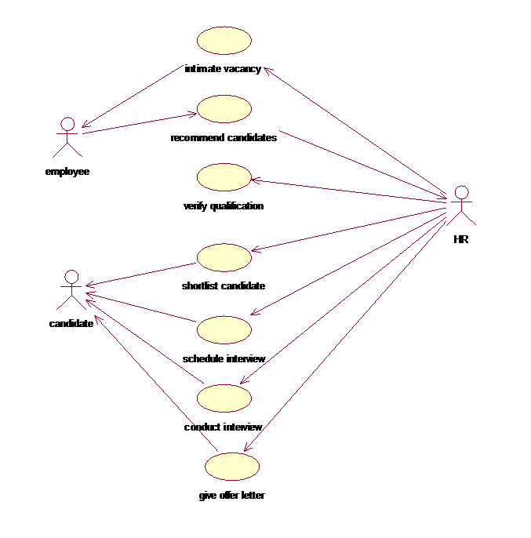

1. **ACTIVITY DIAGRAM:**

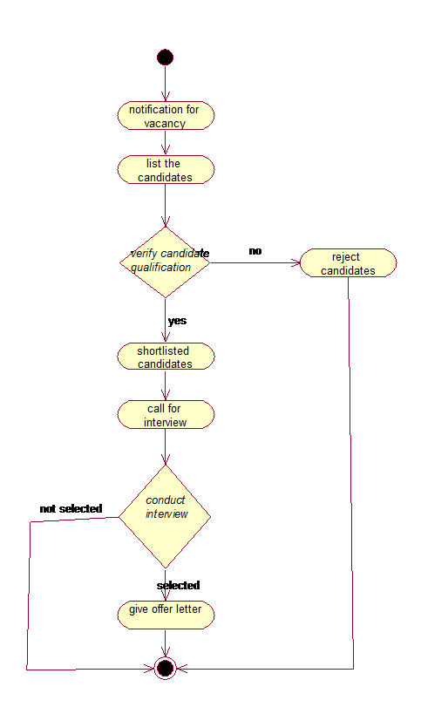

1. **SEQUENCE DIAGRAM:**

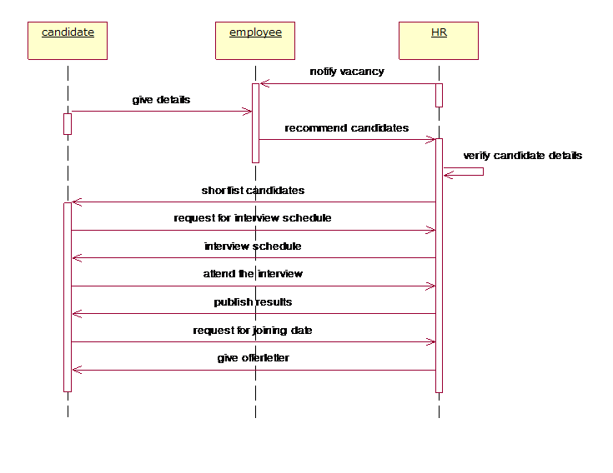

1. **COLLABORATION DIAGRAM:**

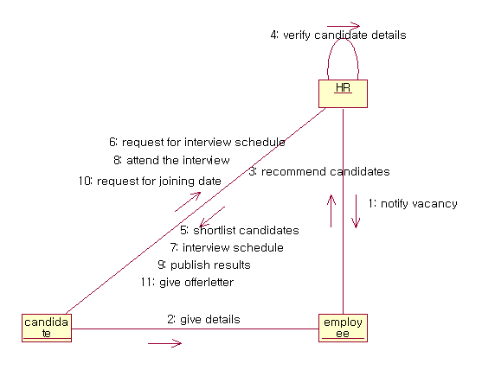

1. **CLASS DIAGRAM:**

